# Larry Page: A Biography

## Introduction

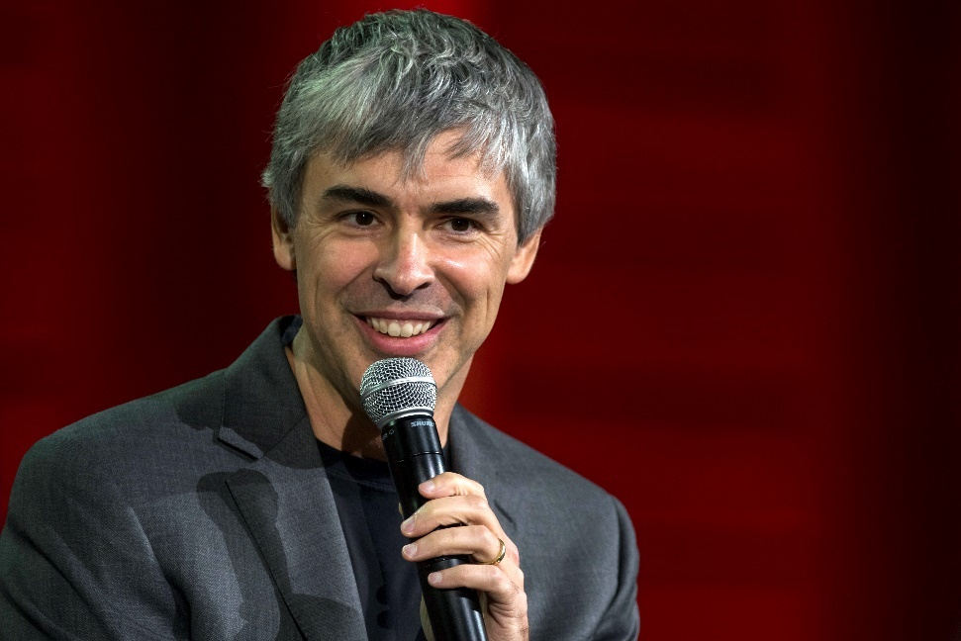Larry Page, or Lawrence Edward Page, is the CEO of Alphabet Inc. He, alongside Sergey Brin, founded Google, as well as PageRank. They wanted “to organise the world’s information and make it universally accessible and useful.” Page appointed himself as CEO of Google right at the beginning in 1998. However, in 2001, he decided to step down until he reprised the role again in 2011. In 2015, he opted to become the CEO of Alphabet Inc instead. He is interested in developing advanced technologies that provide for people’s needs and shorten the workweek. He is looking to create ease and efficiency in people’s lives through technology. Page is number ten on Forbe’s list of billionaires as of October 2019. In 2007, Page married Lucinda Southworth. They have two children together.

## Background

Page was born and bred in Michigan, USA. He was born into a Jewish family, but does not follow any formal religion. He is the child of two very successful people in computer science. Page’s father, Carl Victor Page, studied computer science in the University of Michigan and he later became a professor at Michigan State University. Carl has been described as a “pioneer in computer science and artificial intelligence” by BBC reporter Will Smale. Page’s mother, Gloria, was equally as successful and was a teacher of computer programming at Michigan State University. Page thrived in his family life, describing his childhood home as “usually a mess, with computers, science, and technology magazines and popular science magazines all over the place." His parents encouraged creativity and innovation in all aspects of life. Due to this creative atmosphere and his parents’ jobs, Page became interested in computers as young as the age of six. He was fortunate enough to be able to play with all types of technology lying around the house. Page even turned in an elementary assignment from a word processor, this was unheard of at the time. He loved to take things apart to fully see and understand how they worked. It was this curiosity that led him to realise what he wanted to do in life. “Probably from when I was 12, I knew I was going to start a company eventually”.

As well excelling in the scientific field, Page was also very musical, studying music composition and played the flute. He attended various musical summer camps as a child. He credits his musical abilities for inspiring impatience and obsession with speed in computing, "In some sense, I feel like music training led to the high-speed legacy of Google for me". While in high school, Page even attended Interlochen Centre for the Arts, where he played the saxophone.

## Education and Meeting Co-Founder Sergey Brin

Page followed in his father’s footsteps and graduated with a Bachelor of Science in computer engineering from the University of Michigan, as well as a Master of Science in computer science from Stanford University. Page has always been innovative and creative. While at the University of Michigan, he decided to reverse-engineer an ink cartridge and build the electronics and mechanics 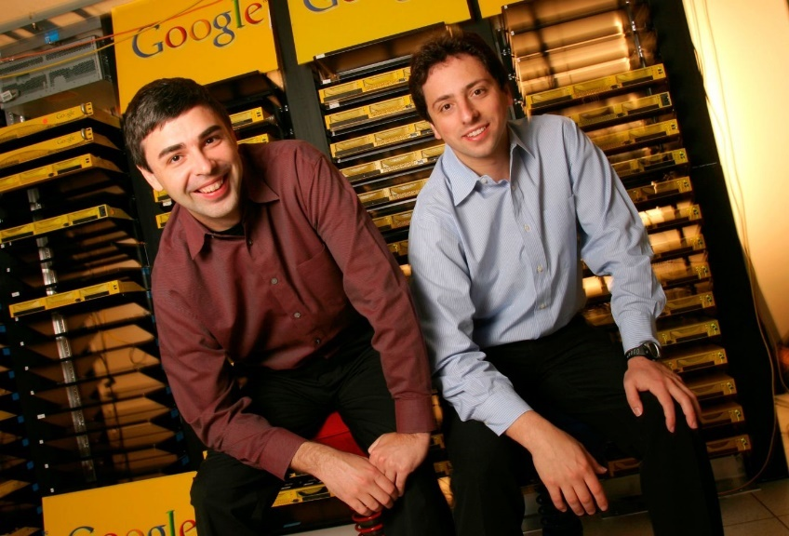needed to run it. The rest of the printer was built out of Lego pieces. He excelled while at university, being the president of his fraternity and proposing ways to improve the school by developing a plan for a PRT System; driverless monorail vehicles with separate cars for passengers, instead of a bus system. He had a mind for computers as well as the leadership qualities of a CEO. He has the drive and imagination to succeed, even developing a business plan for a company to build music synthesizers using software while still at university.

In need of a dissertation theme as a PhD student at Stanford, Page decided to delve into the mathematical properties of the World Wide Web. While this is the theme he eventually stuck with, Page looked into research on telepresence and self-driving cars. He had a keen interest in developing futuristic projects. Page’s research for his PhD gave him the insight and knowledge that would eventually lead to him founding Google. It was around this time that Page met fellow software engineer, Sergey Brin, another PhD student who would have a great impact on his research and future. They worked together on Page’s project, nicknamed “BackRub,” and wrote a research paper together, “The Anatomy of a Large-Scale Hypertextual Web Search Engine.” This paper became one of the most downloaded scientific documents in history.

## Further Research and the First Version of Google

While carrying out their research at Stanford, Brin and Page developed a PageRank algorithm. It was then that they realised they could build a search engineer far better than any of the existing ones at the time. The ambitious duo turned Page’s dorm room into a computer lab where they pulled parts from cheap computers to make a machine that could be used to connect their early search engine with Stanford's broadband campus network. They then proceeded to turn Brin’s dorm into an office and an area to program. The project was written in Java and Python while Page used his rudimentary HTML skills to set up a basic search page for users. The search engine grew in popularity amongst Stanford students and required more servers to process the growing number of queries. In 1996, two years before the official launching of Google, its original version was made available to internet users, still connected to the Stanford University website.

## Image result for larry page googleFounding of Google and Career

Buying servers and renting out a garage using capital from family and friends, in 1998 Google Inc was incorporated. Initially, the domain name was actually Googol. The name represents the amount of data the search engine was intended to explore, coming from a number that consists of one followed by one hundred zeros. Page became CEO while Brin became president. By 2000, Google had become the most comprehensive search engine on the web.

As Google grew, external project managers had been brought in to supervise engineers. However, in 2001, Page decided he wanted to end this as he didn’t like non-engineers managing engineers as they have limited technical knowledge. He encouraged his employees not to delegate as doing everything yourself is much faster. He said to get out of the way if you are not adding value and to go find something else to do instead. This attitude somewhat stifled learning and innovation but he believed the worst thing you could do is to stop someone from doing something by just saying no, you must instead offer up an alternative plan. He wanted his employees to generate ideas and be as creative as possible. It didn’t matter what age you were, age didn’t grant seniority. This leadership model resulted many dissatisfied employees. Nevertheless, his concept of having only engineers managing engineers became common practice in Silicon Valley. It was around this time that Page decided to step down as CEO and become President of Products while Eric Schmidt assumed the role. He remained the boss in the eyes of the employees and still made all final decisions on behalf of the company.

Page had hoped that handheld computers would be in the possession of consumers so they could gain access to Google anywhere and at any time. This led to Google’s acquisition of Android. In his second tenure as CEO in 2011, Page strived for greater autonomy amongst executives and better collaboration, communication and unity throughout the company. In contrast to his original approach as CEO where he would use his arguments with Brin as an example for senior management, Page announced a new “zero tolerance for fighting” policy.

## Environmental Impact

Page is very environmentally conscious, having invested a large sum of money into renewable energy technology and enlisting the support of Google.org, the philanthropic branch of Google. Page acquired many of the properties surrounding his home in Palo Alto, with the intention to demolish them and make room for his Eco house. The materials of the demolished buildings were donated for reuse elsewhere. He hopes to minimise his environmental footprint. He enlisted the help of an arborist to replace dying trees with ones that require less water, making them easier to maintain. His house contains features constructed of low or no-VOC materials as well as rooftop gardens and solar panels. He built his house as eco-friendly as possible and even applied for Green Point Certification.

## Health and Philanthropy

Page has Hashimoto’s thyroiditis, an autoimmune disease that caused the paralysis of his vocal cords. His left vocal cord was paralysed in 1999, while the right was paralysed in 2013. Due to his condition, he donated millions of dollars to the vocal-cord nerve-function research program at the Voice Health Institute in Boston.

In 2013, Page’s family foundation, the Carl Victor Page Foundation, donated $15 million to combat the Ebola virus epidemic in West Africa.

## Awards and Accolades

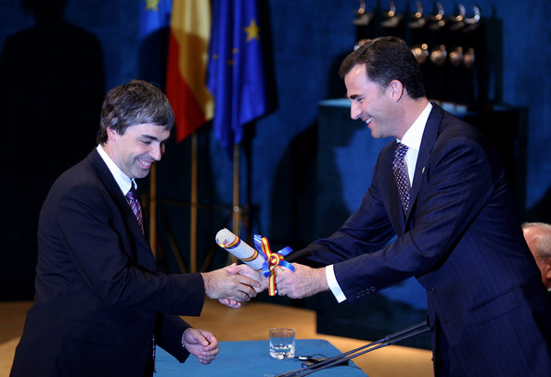Page has far too many awards and achievements to list all of them here. Some of his most notable are as follows. In 2002, Page and Brin were named as two of the top 100 innovators in the world under 35 by MIT’s Technology Review. That same year, Page was awarded the title of Global Leader for Tomorrow by The World Economic Forum. In 2004, Page and Brin were presented with the Marconi Foundation Prize, this is given for important contributions in science and technology. They were also made Fellows of the Marconi Foundation. Page was named “Business Person of the Year” by Fortune magazine, who referred to him as “the world’s most daring CEO.”

## Impact

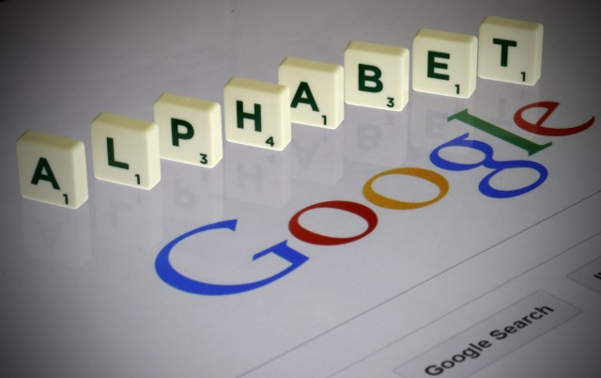Page has changed the way we live our day to day lives with the development of Google. Many don’t go a day without googling something or signing into a google account, whether that be my Gmail or YouTube. According to Wayback Machine, some have even compared him and Brin to Johannes Gutenberg, the inventor of the printing press; “in 1440, Johannes Gutenberg introduced Europe to the mechanical printing press, printing Bibles for mass consumption. The technology allowed for books and manuscripts – originally replicated by hand – to be printed at a much faster rate, thus spreading knowledge and helping to usher in the European Renaissance ... Google has done a similar job.” I doubt even Page himself could’ve imagined the effect and influence he would have. Google is the number one search engine and one of the most influential technological companies out there. In 2015, Forbes wrote a “Powerful People” profile on Page and stated that Google is “the most influential company of the digital era.”

## References

Scott, Virginia A. (October, 2008). *Google / Virginia Scott*. Corporations That Changed the World. Westport, Connecticut; London: Greenwood Press. p. 2

Smale, W. (April, 2004). *BBC NEWS | Business | Profile: The Google founders*. [online] News.bbc.co.uk. Available at: http://news.bbc.co.uk/2/hi/business/3666241.stm [Accessed 15 Oct. 2019].

Helft, M. (2014). *How music education influenced Google CEO Larry Page*. [online] Fortune. Available at: https://fortune.com/2014/11/18/larry-page-music-education/ [Accessed Oct. 2019]

Forbes. (2019). *Larry Page*. [online] Available at: https://www.forbes.com/profile/larry-page/#3b3670627893 [Accessed 12 Oct. 2019].

Biography. (2014). *Larry Page*. [online] Available at: https://www.biography.com/scientist/larry-page [Accessed 13 Oct. 2019].

Schmidt, E., Rosenberg J. (2015). *How Google Works.* Great Britain, John Murray Publishers.

Academy of Achievement. (2018). *Larry Page | Academy of Achievement*. [online] Available at: https://www.achievement.org/achiever/larry-page/ [Accessed 17 Oct. 2019].

Thefamouspeople.com. (2019). *Who is Larry Page? Everything You Need to Know*. [online] Available at: https://www.thefamouspeople.com/profiles/larry-page-3344.php [Accessed 16 Oct. 2019].